Preparing the data
I used JMP to prepare the dataset before loading it to Python.

Prepping Features (JMP)

Basin Code (BCode)
This is coded as a short string. Many of the basins have only one observation in the dataset whereas there are about a dozen with tens to hundreds of observations.
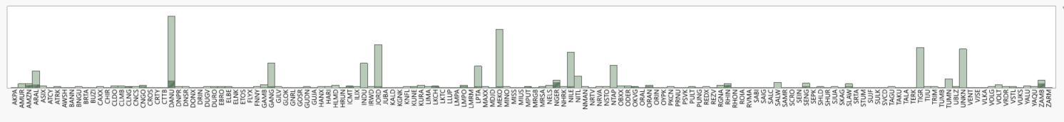

Issue Type1
The original variable is coded with numbers from 0 to 13. I renamed the data in a new feature called Issue_Cat.
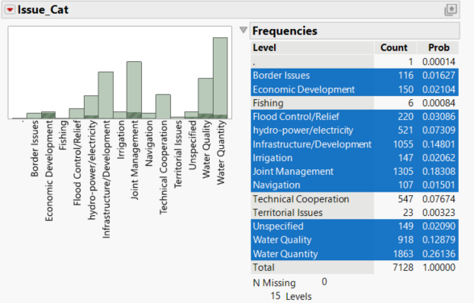

Issue Area | Description
Water Quality | Concerns about pollution, contamination, or standards for water quality.
Water Supply / Development Project | Issues related to water quantity, allocation, or infrastructure projects (e.g., dams, reservoirs).
Hydropower | Development or operation of hydroelectric facilities and related agreements.
Navigation | Use of waterways for transportation or navigation rights.
Fishing | Access to or management of fisheries in shared waters.
Flood Control | Measures or disputes related to flood prevention and management.
Economic Development | Projects or agreements tied to economic growth involving water resources.
Joint Management | Cooperative efforts for integrated water resource management across borders.
Irrigation | Agricultural water use
Infrastructure/Development | Dams, canals, drainage projects
Technical Cooperation/Assistance | Surveys, evaluations, funding for improvements
Border Issues | Rivers as shared borders/boundaries
Territorial Issues | Territorial claims linked to water bodies (e.g. river islands)
Unspecified | General Water Issue

Basins at Risk (BAR) scale
This is coded as -7 to 6 (there are no -7s in the dataset). I aggregated and recoded the variable with descriptive names.
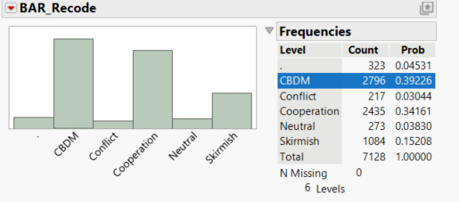

Data
Original Date feature is coded as day/month/year (xx/xx/xxxx). I recoded into a new “year” feature aggregating the data by year.
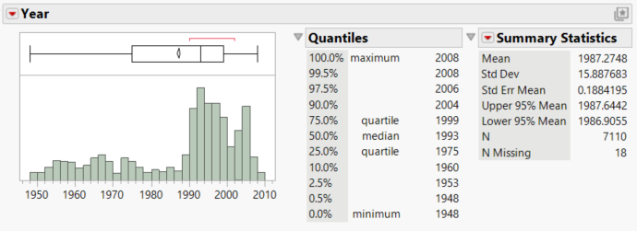
There is much more data for the later years. I needed to take this into consideration when splitting the data by year. In order to get enough (80%) of the data in the early years, I had to make the cutoff 1999 (See below).

Python Analysis

Loading the Data
I loaded the new variables I created, plus the original BAR Scale and Issue Type, I also loaded Country Codes and number of countries. I loaded the unique ID thinking that it might be useful, but I am not sure how.
I loaded the two country code variables, but I don’t know how I would use those in an analysis.
I thought number of countries might tell us something but not using it in the original analysis.
Loaded Features List: [UNIQUE_ID', 'DATE', 'Year', 'BCode', 'CCODE1', 'CCODE2', 'NUMBER_OF_Countries', 'BAR_Scale', 'BAR_Recode', 'Issue_Type1', 'Issue_Cat']
descriptive statistics for the loaded features:
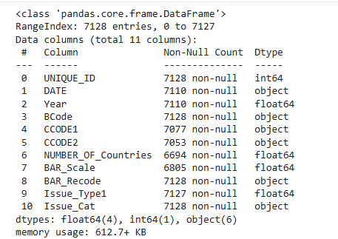
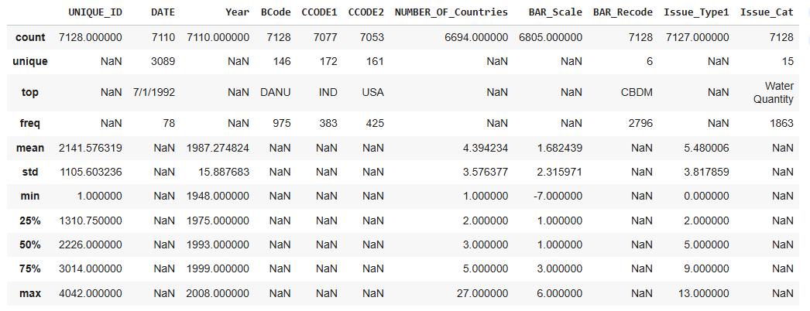
After loading features, I dropped the ones that I am not planning to use yet. (is there a better way? Should I not load these features yet?)

Missing Values
I am never 100% sure if I should remove all of the rows where there are features missing, but it doesn’t make sense to me to compute values (e.g. most common, average). for any missing features given the data type and sources. I dropped rows with missing values in features I planned to use. This left the dataset with 6,362 instances.
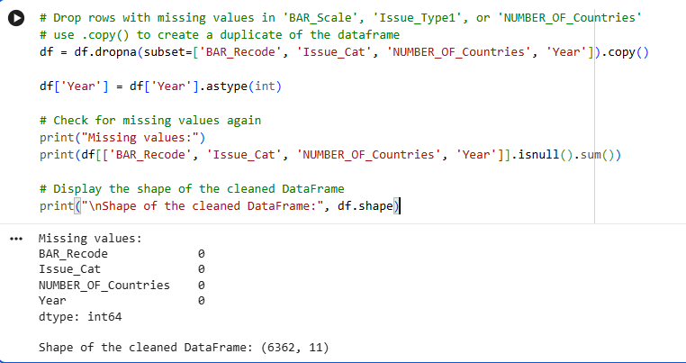

One Hot Encoding
Recoded Issue_Cat, BCode, Bar_Recode using one-hot-encoding and renamed all the features to eliminate white spaces:
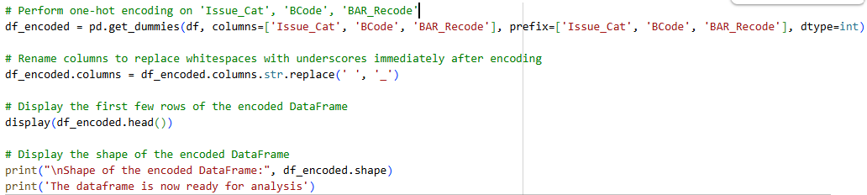

Splitting the Data
To split the data by year and have roughly 10% for training and 10% for validation, I made the training cutoff 1999 and split the remaining data into test and validation data.
I tried to split with a cutoff of 1970, but that did not allow sufficient training data.
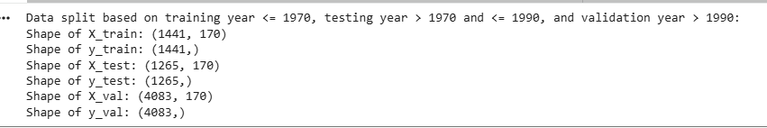
Code for splitting the data:
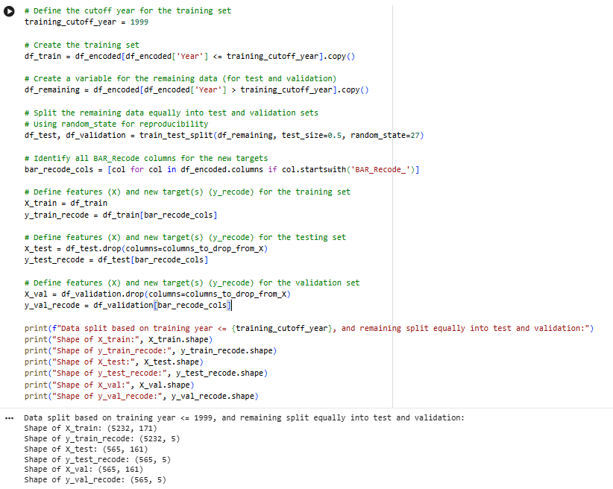
The training set has all the features from one one-hot-encoding. Total number of features is 167.

Random Forest Classifier
I ran a baseline RFC
